1.C is for low-level software development.

Like WeChat, drive or operating system.

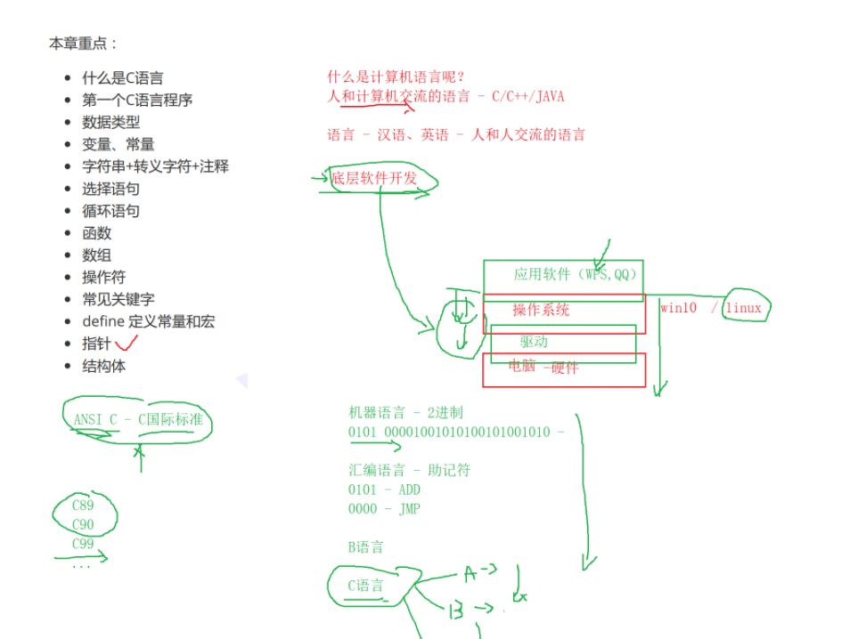

2. bit and byte

1 byte = 8 bits

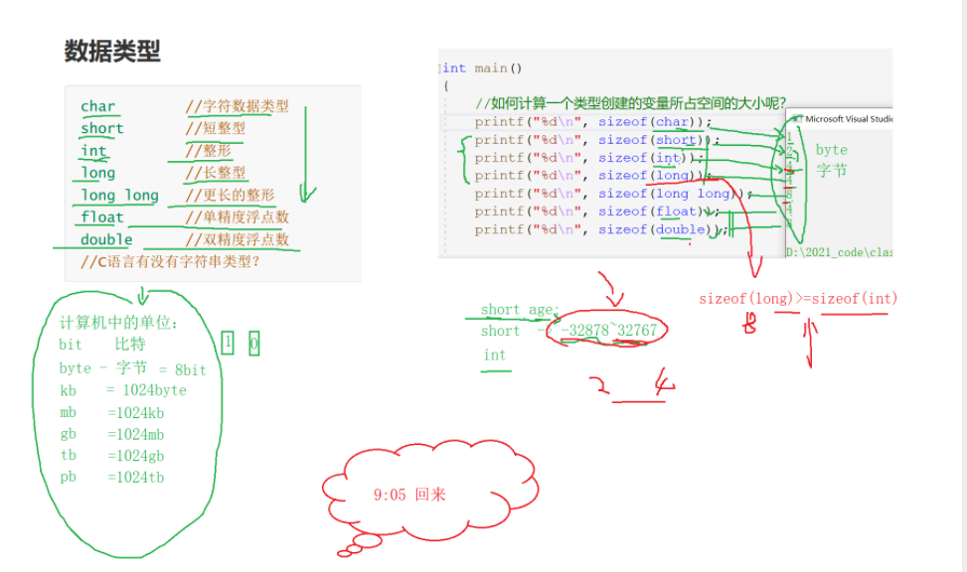

3 ACCII chart

Just an example

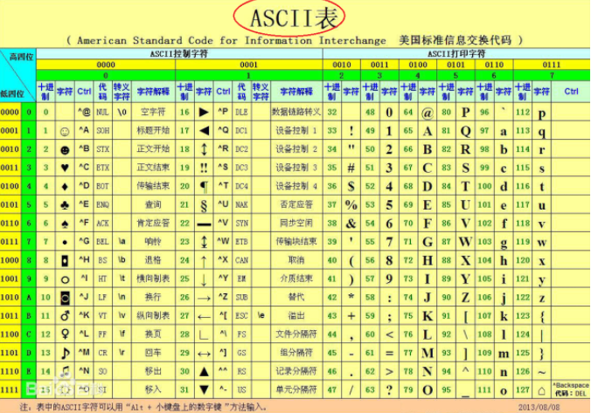

4 global scope variable and local scope variables

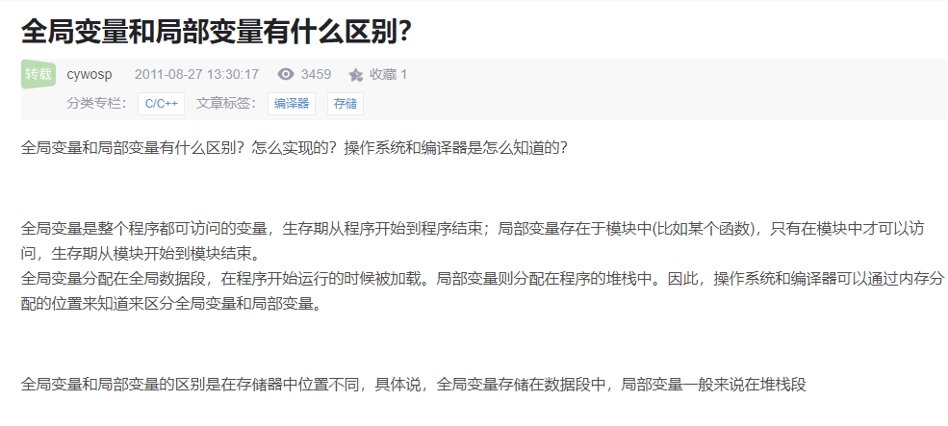

Global variables are initialized and loaded when the program start, local variables is stored into temp memory.

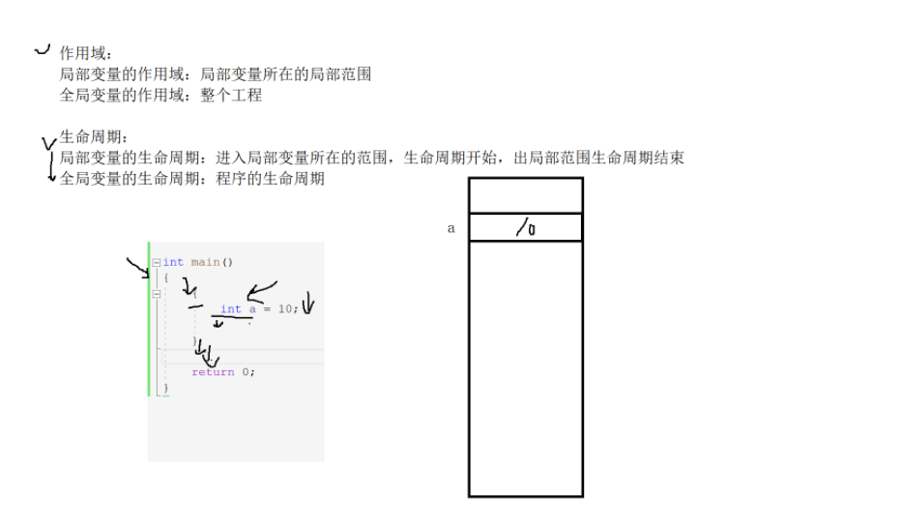

Lec2

5. C mainly has 4 following types

Normal variables 1 , 2 , 3

Const -> constant variables const int num = 1; (it can’t be changed)

#define variables

And Enum variables

6:

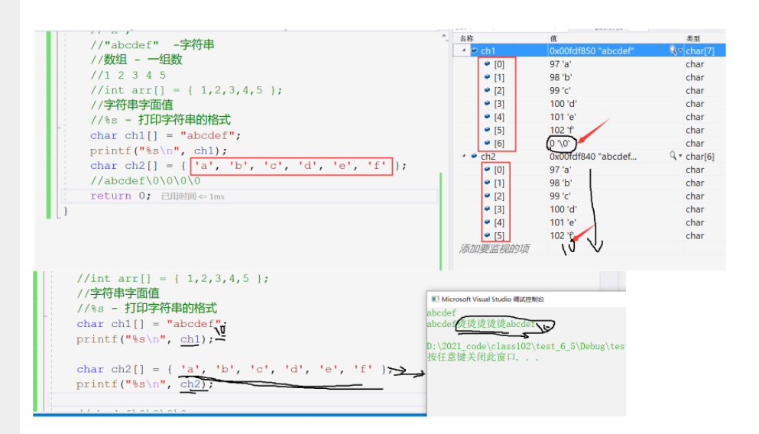

Lec 3:

1: C operators

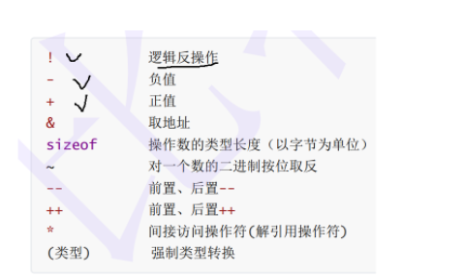

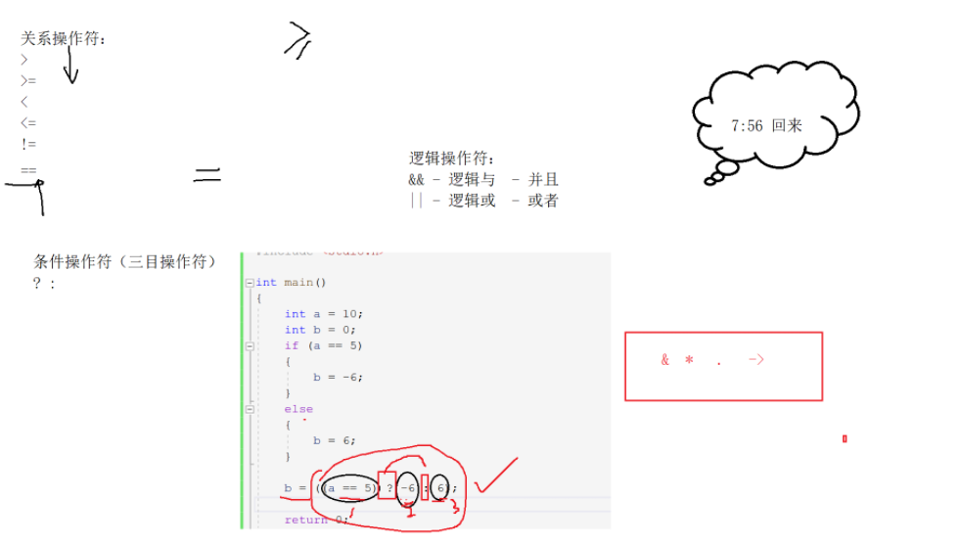

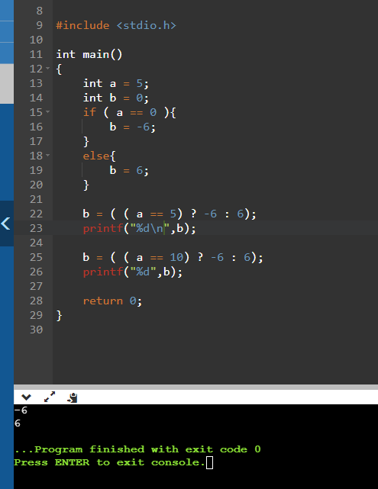

If statement a == 5 return true, then it will be -6

If statement a == 10 return false, then it will be 6.

2 how to use static

